**GC Docs Mobility Project**

Active View installation

for Alpha release

# Revision History

|  |  |  |  |
| --- | --- | --- | --- |
| **Date** | **Version** | **Contributor(s)** | **Description** |
| 2017-04-12 | v0.1 | Rudy Hallé | First Draft |
|  |  |  |  |
|  |  |  |  |
|  |  |  |  |
|  |  |  |  |
|  |  |  |  |

## Copy support files to Content Server’s server

1. Copy the support files under \CS105\support\custom
   * **addversionXL.gif**
   * **BB10_ActiveView.css**
   * **cookieHistory.js**
   * **ico-doc-addXL.gif**
   * **ico-folder-addXL.gif**

## Import Custom Files

### ActiveView Pages

1. Create ActiveView_Volume or other directory to regroup ActiveView Pages
2. Open folder created in step a)
3. Add new ActiveView document

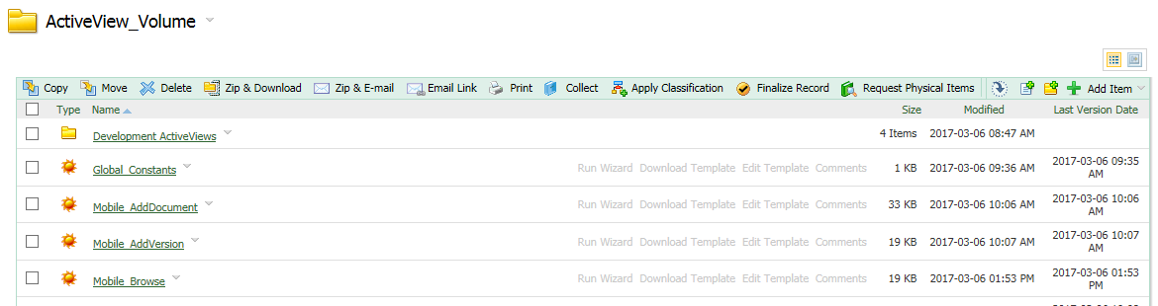

1. Select Browse and select file (ActiveView name will be autopopulated)

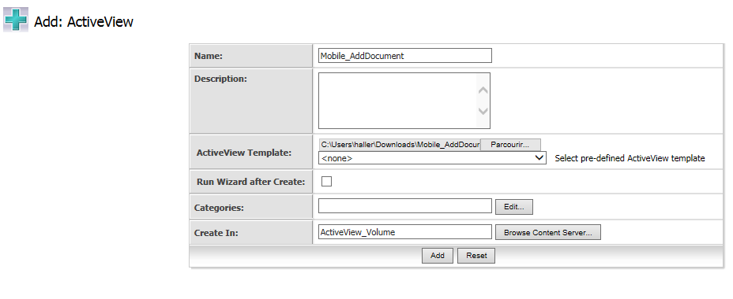

1. Click Add
2. Repeat for all ActiveView Files

### WebReport Page for Recent Documents

*(Final directory location to be defined)*

1. Click **Add Item** 🡪 **WebReport**
2. Select source by clicking **Browse Content Server**
   * Content Server Reports 🡪 My Recently Viewed Documents

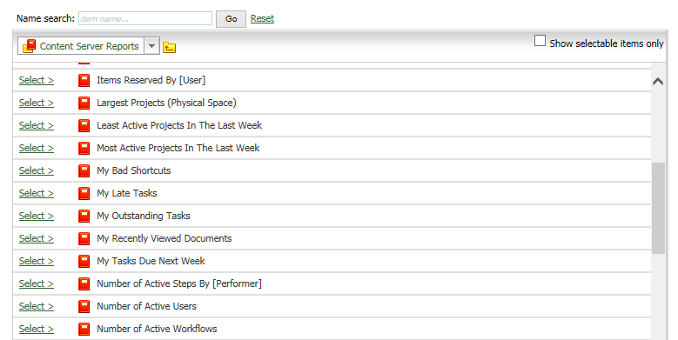

1. Select **Reportview file : Browse** and select **Mobile_RecentDocument_WebReport** (WebReport name will be autopopulated)

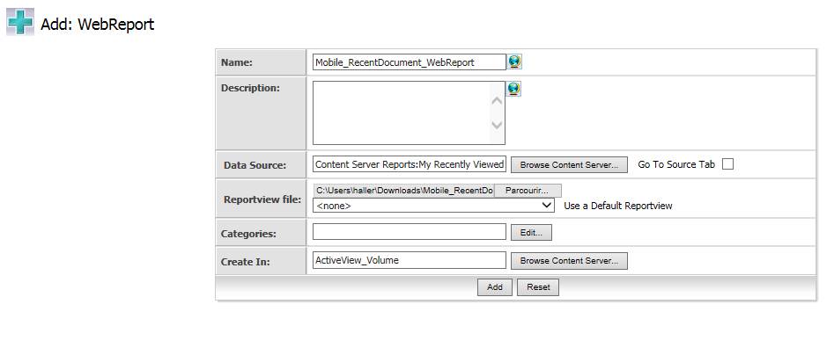

1. Click **Add**

## Set Constants

### Set Recent Document Global Constant

1. Click the function Menu of the Global_Constants ActiveView page
2. Select Properties🡪Constants

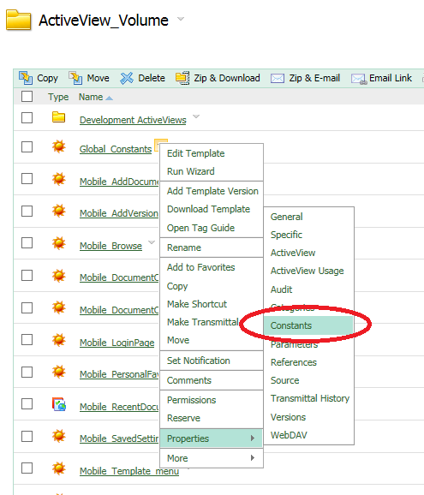

1. Define a new constant
   * Name : **mobile_RecentDocID**
   * Constant Value : **Mobile_RecentDocument_WebReport ID** *(click browse to select it)*

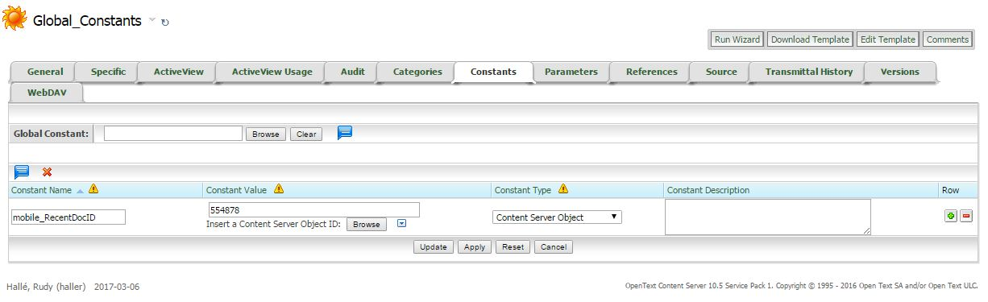

### Link Global Constants for each ActiveView Page

1. Click the function Menu of the Global_Constants ActiveView page
2. Select Properties🡪Constants

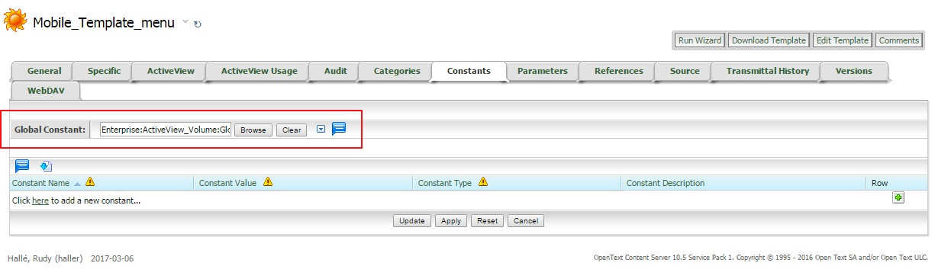

## Activate features within Content Server

### Log in to Content Server Administration Pages

### Under ActiveView Administration 🡪 Content Server ActiveView Licensing

1. Confirm license information

### Under Activeview Administration 🡪 Administer Login Page User

1. Set current user to allow login page modification

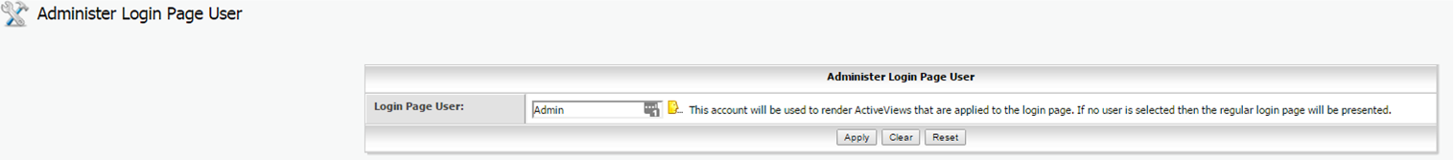

### Under ActiveView Administration 🡪 Allow AVID in URL

1. Check “Allow AVID In URL” and “Allow AVID=0 In URL”
2. Unchek “Allow AVID=0 In URL Admin Only”

### Under ActiveView Administration 🡪 Enable Or Disable ActiveView Override Types

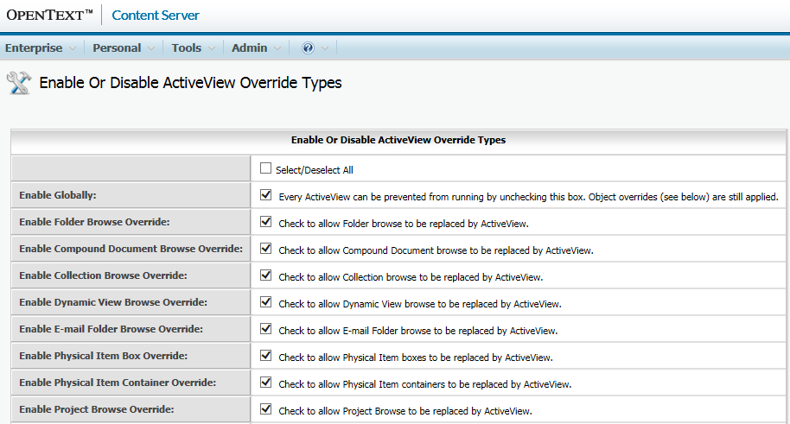

1. Select all

### Under ActiveView Administration 🡪 Manage Global ActiveView Overrides

1. Set Desired Overrides with condition

**"(BB10" IN "[LL_REPTAG_&HTTP_USER_AGENT /]"**

**Container Browse Overrides**

Folder Browse: Mobile_Browse

Compound Document Browse: Mobile_Browse

Collection Browse: Mobile_Browse

Project Browse: Mobile_Browse

Personal Workspace Browse: Mobile_Browse

Virtual Folder Browse: Mobile_Browse

**Personal Report Overrides**

Personal Favorites Page: Mobile_PersonalFavorites

**Miscellaneous Component Modifications**

Add Item Page: Mobile_AddDocument

Document Overview: Mobile_DocumentOverview / Mobile_DocumentOverview2 (style variation)

Login Page: Mobile_LoginPage

Properties Tabs: Mobile_DocumentOverview

**Property Tab Overrides**

General Tab: Mobile_DocumentOverview

1. Set Generic Request Handlers to point to the following ActiveView Pages
   * **func=personal.settings 🡪 Mobile_SavedSettings**
   * **func=doc.AddVersion 🡪Mobile_AddVersion**

